CODING CHALLENGE (VIRTUAL ART GALLERY)

1)Creating the Artists table

2) Creating Categories table

3) Create the Artworks table

4) Create the Exhibitions table

5) Create a table to associate artworks with exhibitions

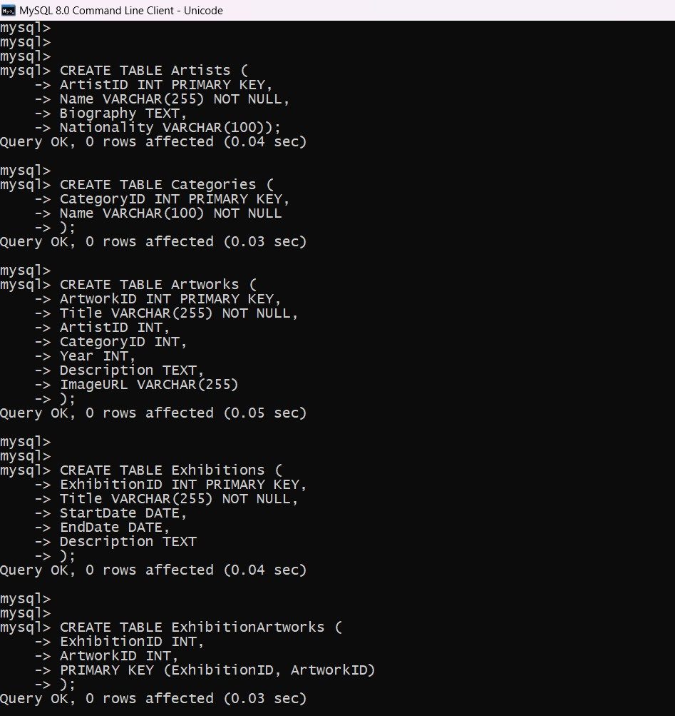

-- Inserting sample data into the Artists table

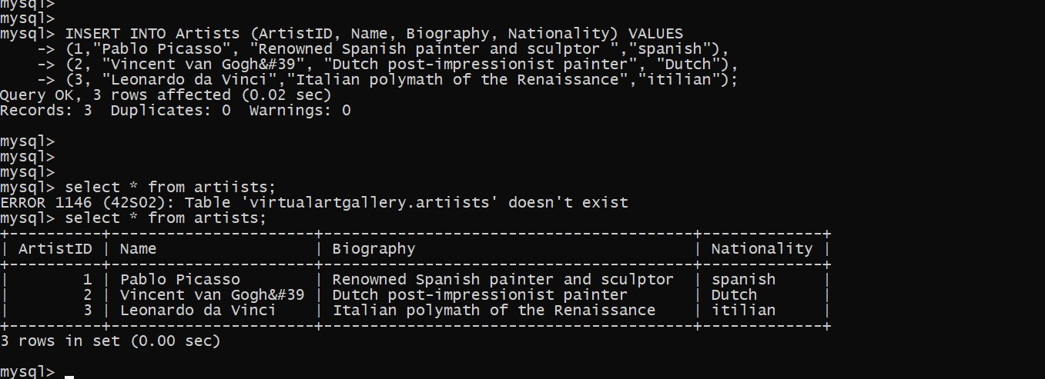

-- Insert sample data into the Categories table

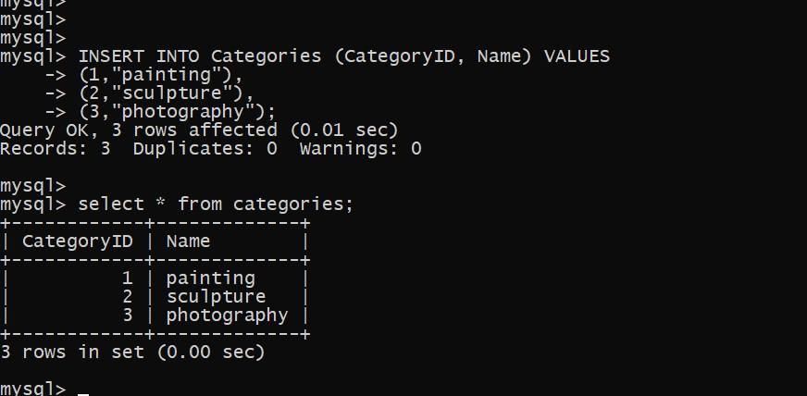

-- Insert sample data into the Artworks table

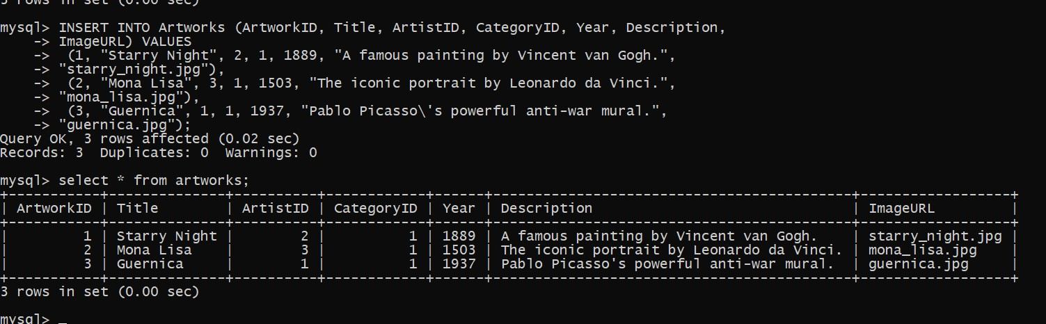

-- Insert sample data into the Exhibitions table

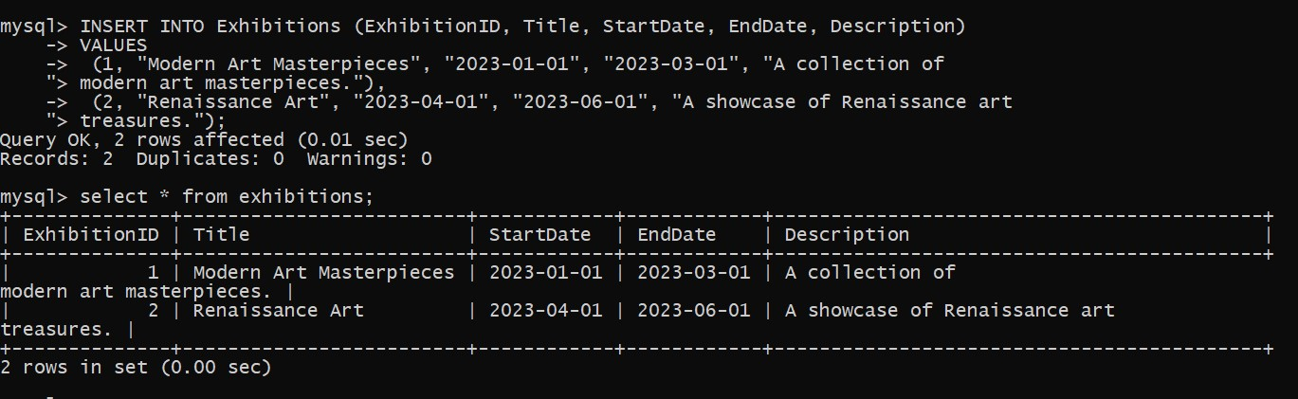

-- Insert artworks into exhibitions

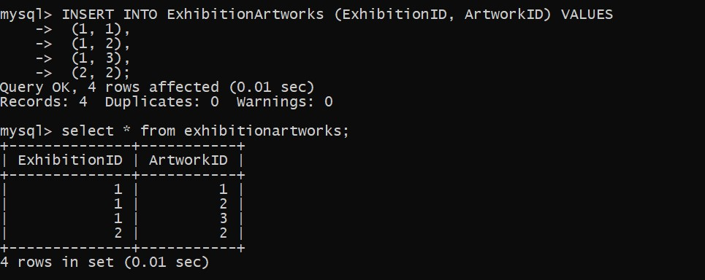

-- 1. Retrieve the names of all artists along with the number of artworks they have in the gallery, and list them in descending order of the number of artworks

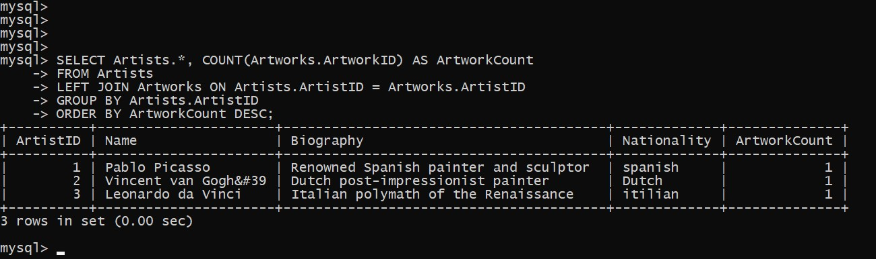

-- 2. List the titles of artworks created by artists from 'Spanish' and 'Dutch' nationalities, and order them by the year in ascending order.

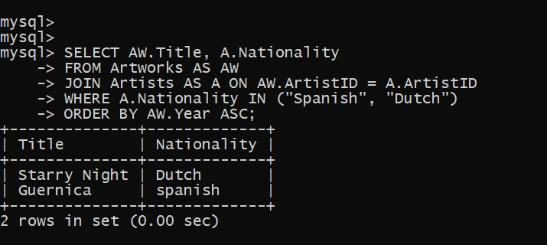

-- 3. Find the names of all artists who have artworks in the 'Painting' category, and the number of artworks they have in this category

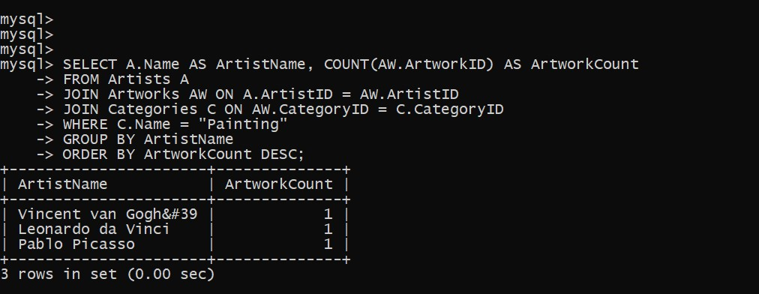

-- 4. List the names of artworks from the 'Modern Art Masterpieces' exhibition, along with their artists and categories

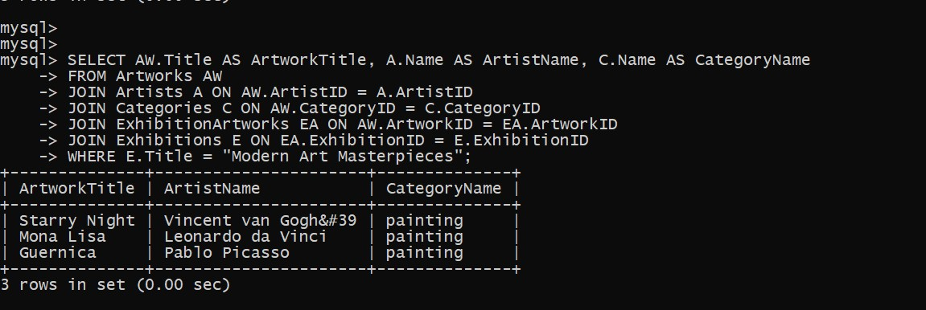

-- 5. Find the artists who have more than two artworks in the gallery.

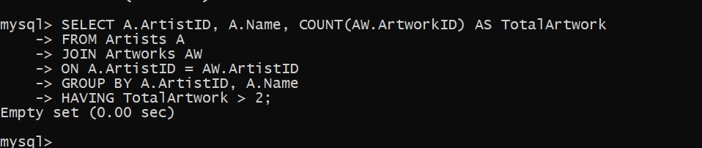

-- 6. Find the titles of artworks that were exhibited in both 'Modern Art Masterpieces' and 'Renaissance Art' exhibitions

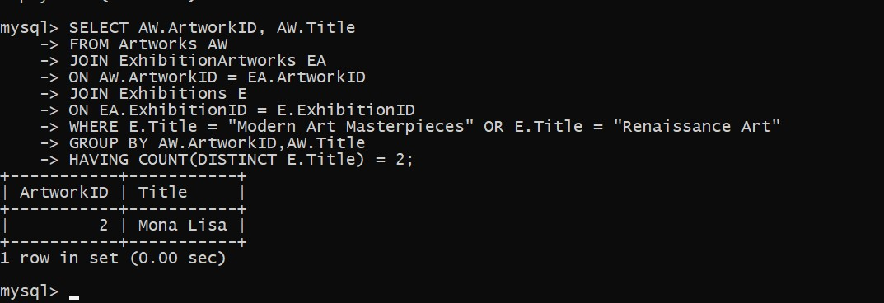

-- 7. Find the total number of artworks in each category

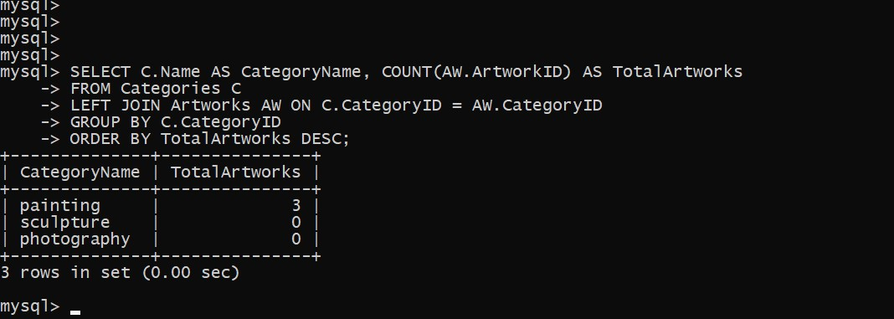

-- 8. List artists who have more than 3 artworks in the gallery

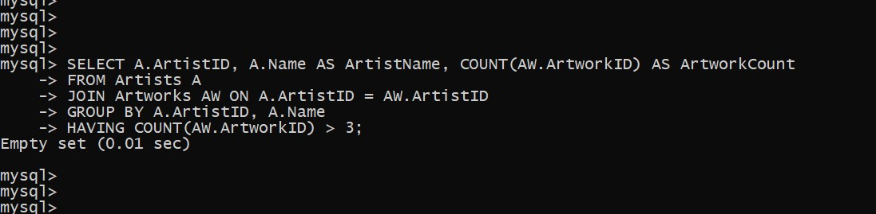

-- 9. Find the artworks created by artists from a specific nationality (e.g., Spanish)

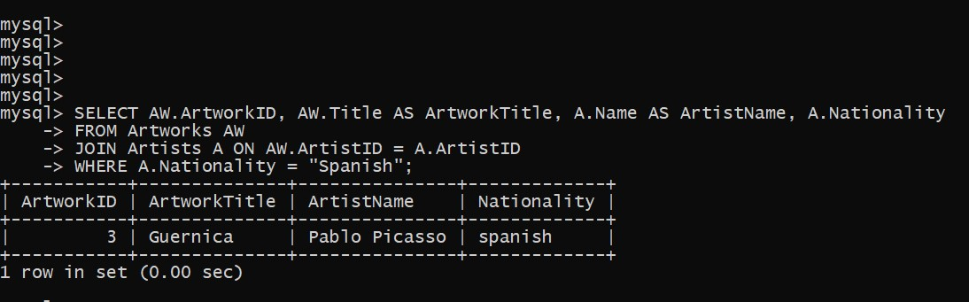

-- 10. List exhibitions that feature artwork by both Vincent van Gogh and Leonardo da Vinci.

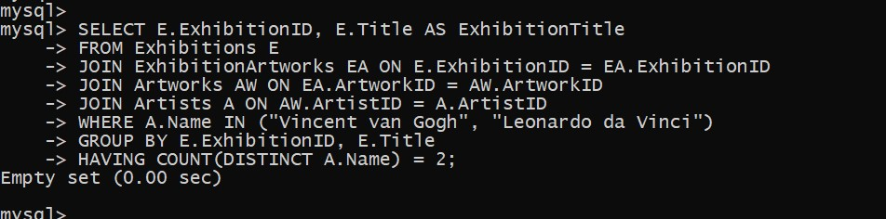

-- 11.Find all the artworks that have not been included in any exhibition.

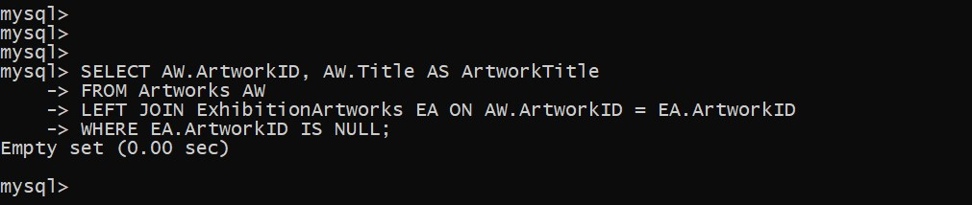

-- 12. List artists who have created artworks in all available categories.

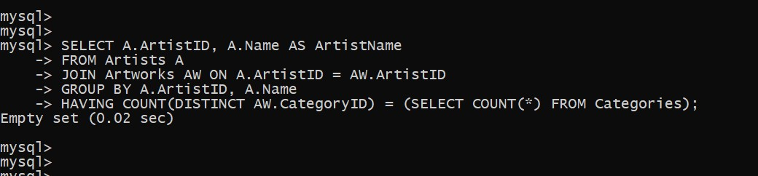

-- 13. List the total number of artworks in each category

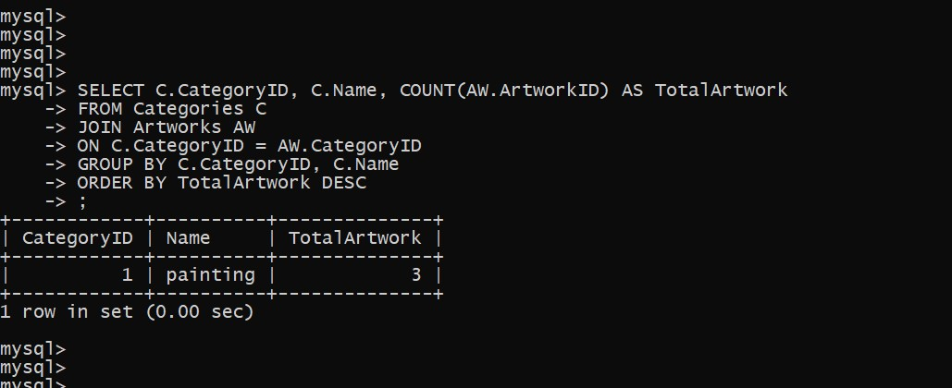

--14 Find The artist who have more then 2 artwork in the gallery

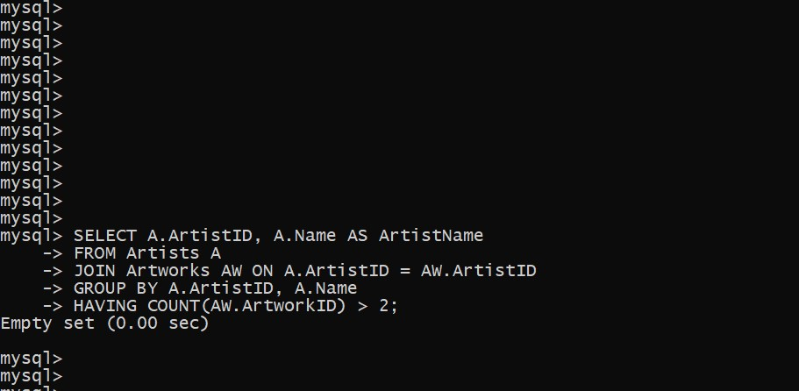

-- 15. List the categories with the average year of artworks they contain, only for categories with more than 1 artwork

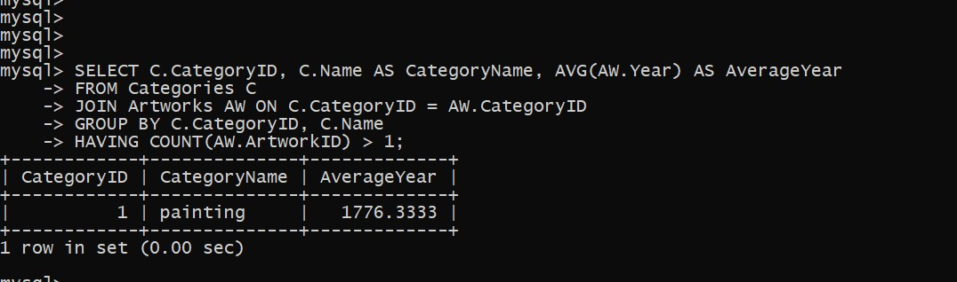

-- 16 Find the artworks that were exhibited in the 'Modern Art Masterpieces' exhibition

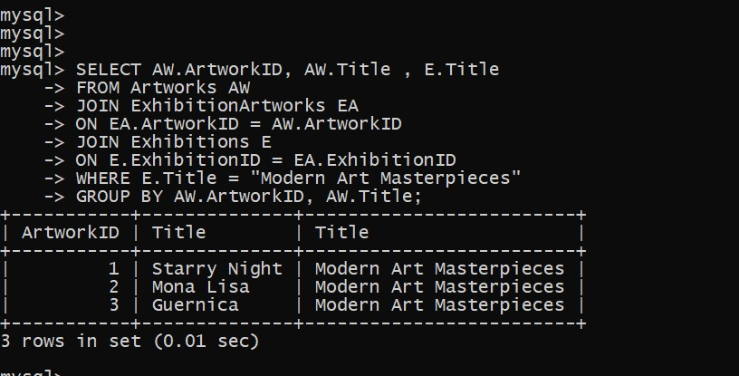

-- 17.Find the categories where the average year of artworks is greater than the average year of all artworks.

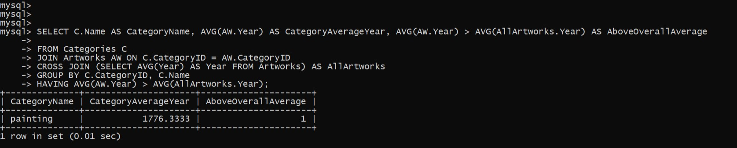

-- 18. List the artworks that were not exhibited in any exhibition

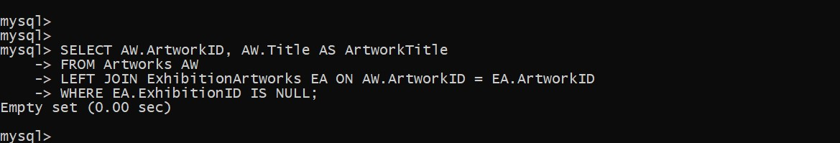

-- 19.Show artists who have artworks in the same category as "Mona Lisa."

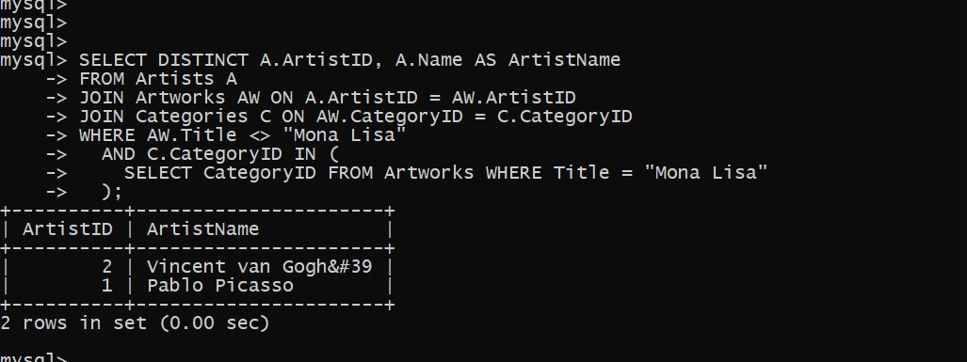

-- 20. List the names of artists and the number of artworks they have in the gallery.

